House of Commons LibNHS Winter Pressures in England, 2017/18

winter pressures in the NHS

Published Tuesday, February 6, 2018

Pressures on the NHS in England in winter 2017/18, including ambulance handover delays, bed occupancy, norovirus bed closures, and accident and emergency diverts.
In the winter months, NHS England releases 'daily situation report' data which measures pressure on acute hospital services. For 2017/18, the data currently covers the period 20th November to 28th January. This short briefing summarises the data and will be updated periodically during the winter.

Ambulance handover delays
127,000 ambulance arrivals at hospital have had their handover delayed by more than 30 minutes since November 20th. This is just under one in seven ambulance arrivals. The chart below shows performance on each day during the period. On 2nd January, one quarter of ambulance handovers were delayed for over 30 mins, and 9% were delayed for over 60 mins.

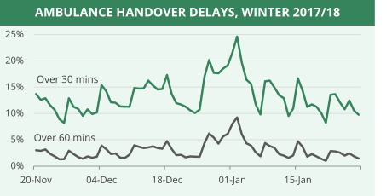

It's not possible to compare this data directly with previous years. During the equivalent period in 2014/15, there were 73,000 recorded ambulance handover delays - 43% fewer than this winter. However, data isn't available to calculate the percentage of handover delays in 2014/15, meaning we can't be sure of the true increase.

Bed occupancy
General & acute bed occupancy in England's hospitals has been above 90% for all but four days since 20th November. On Tuesday 23rd January occupancy was 96% - the highest so far this winter. Occupancy was below 85% on only one day - Christmas eve. Occupancy has been above 95% for 30 of the 70 days in the winter period.

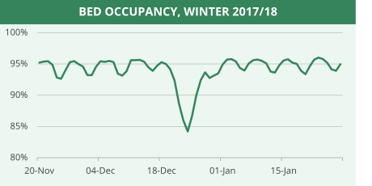

Bed occupancy was slightly higher than last winter over the Christmas and New Year periods. However, in recent weeks there has been little difference.

Occupancy levels vary substantially at different hospitals. On most days, over 20 NHS trusts have recorded bed occupancy over 98%. On 2nd January, 57 of 137 trusts had bed occupancy above 98%.

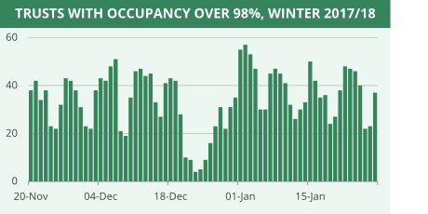

Walsall Healthcare NHS Trust has reported 100% occupancy for 55 of 70 days this winter. Seven other trusts have been at 100% occupancy for more than 20 days: North Middlesex, Hillingdon, James Paget (Great Yarmouth), Barnsley, Princess Alexandra (Harlow), Leeds, and Weston Area.

Escalation beds open
An escalation bed is a designated ward bed that is usually closed as it is additional to a trust's funded and staffed bed stock. The number of escalation beds open is, therefore, one measure of pressure in the NHS.

The number of escalation beds peaked on 2nd January at 5,075 - 5.1% of all beds open on that day.

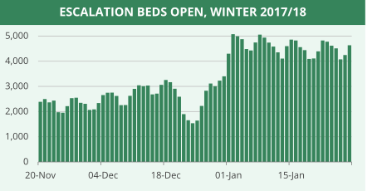
Norovirus bed closures
There have been 56,424 bed days lost to norovirus closures since 20th November. Over comparable dates, the level of norovirus closures has been 9% higher than last winter.

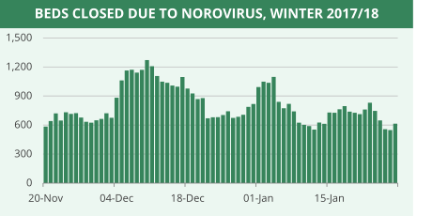

St George's University Hospital NHS Foundation Trust, King's College London NHS Foundation Trust, and Taunton & Somerset NHS Foundation Trust have had the highest number of bed days lost to norovirus closures. As a proportion of beds available, closures have been highest at Weston Area NHS Trust. Ten trusts account for almost 40% of closures.

Accident and Emergency Diverts
Since 20th November, there have been 251 occasions where a temporary divert between A&E departments was set up to alleviate pressure. Over comparable dates, diverts are 37% lower than last winter. This difference was particularly pronounced in the first two weeks of January. However, 2017/18 diverts increased again at the end of January.
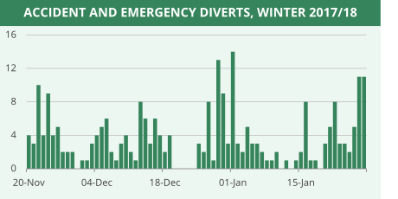
32% of diverts in England this winter are due to two NHS trusts: Worcestershire Acute Hospitals NHS Trust, and Gloucestershire Hospitals NHS Foundation Trust. Twelve trusts have had five or more diverts this winter.

NHS 111
NHS 111 is a non-emergency telephone line for healthcare advice. The number of calls answered by NHS 111 this winter has been around 30,000 on weekdays, and around double this number on weekends. The highest number of calls was 86,359 on Saturday 23rd December.

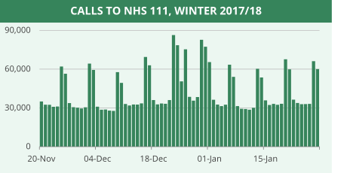

The percentage of calls not answered within 60 seconds has been higher than last winter. So far this winter, 25% of calls have taken longer than 60 seconds to answer, which is higher than in 2016/17.

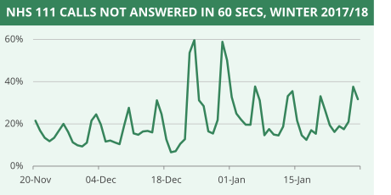
On Christmas Eve, 60% of calls took longer than 60 seconds to be answered. This compares with a peak last winter of 36% on 27 December.

In 2016/17, information on which NHS trusts have declared OPEL pressure alerts each day has been published. This was billed as a way to streamline reporting and "provide a common language" of pressure. However, this data is not being released in the public dataset in 2017/18.

NHS England has stated in the past that the winter dataset is subject to only minimal validation because it is turned around quickly, but that it is nevertheless "fit for purpose".
This briefing will be updated periodically as new data is published during winter 2017/18.

Commons Briefing papers CBP-8210
Author: Carl Baker
Topics: Ambulance services, Emergency services, Health services
Share this page

