Hospital Handover

**EXECUTIVE SUMMARY**

**Ambulance Response Programme - Summary**

* A total of **1,291 hours** were **lost** at hospital during patient handover.
* **142 hours were lost at Northwick Park. This is 11% of all hours lost at hospital across London.**

Performance



Demand

* **21,647 Incidents were provided with a face-to-face response.**
* Last week **12,236** incidents were categorised as **Category 2** and provided with a face-to-face response.

**LAST WEEK OVERVIEW**

* The Mean response time for **C1** was **7 minutes 1 second**.
* The **C1 90th Centile** was **11 minutes 43 seconds**. This has remained **within** the 15 minute national standard for **12 consecutive weeks**.

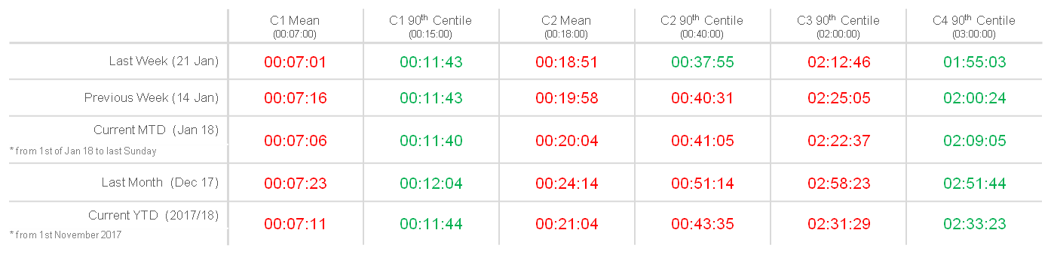

* The average time taken to answer a call was **12 seconds, 4** seconds lower than last week.
* **80.8% of callers received an answer within 5 seconds, an increase of 5%.**



Call Answering